# Caremark.com - Auto Refill & Renewals

Scenario/Member Statements

 Automatic Refill and Renewals Enrollment

 Turn on Auto Refill

 Turn off Auto Refill

 Auto Fill Date after 16-day hold period

Related Documents

** Description:** This work instruction provides the steps members can take to enroll and unenroll their prescriptions in Automatic Refill and Renewal.

|  |
| --- |
| Scenario/Member Statements |

I want to have my medications sent to me without having to request them. Is there a program I can use to do that?

I have a lot of medications that I sometimes forget to order until I only have one left. Can you help manage them for me?

Top of the Document

|  |
| --- |
| Automatic Refill and Renewals Enrollment |

Enrollment in ReadyFill program is managed from **My Prescriptions.**

Prescriptions eligible for the ReadyFill program show an Auto refill toggle button. If the toggle is gray with an “x,” the prescription is not enrolled in the ReadyFill program. If the toggle is green with a “check,” the prescription is enrolled in the ReadyFill program.

**Note:** If a client offers both **Auto Refill and Auto Renewal**, the member will be enrolled in both.

* **If the member does not want to be enrolled in both Auto Refill and Auto Renewal, member can contact Customer Care to manage the enrollment preferences in Compass.**

Members are also able to enroll in the ReadyFill program during the checkout flow.

Top of the Document

|  |
| --- |
| Turn on Auto Refill |

Auto refill can be **turned on** by moving the Auto refill toggle button to the right OR from the Options menu.

When turning **Auto refill on**, members are provided with details regarding enrollment and must agree to the Terms and Conditions.

* Click **I agree to the Terms and Conditions**.
* Click **Confirm**.

**Result:** The toggle button is green with a “check.”

* Confirmation of enrollment is provided at the top of the page.

**Note:** Members are also able to enroll in the ReadyFill program during the checkout flow.

Top of the Document

|  |
| --- |
| Turn off Auto Refill |

Auto refill can be **turned off** by moving the Auto refill toggle button to the left OR from the Options menu.

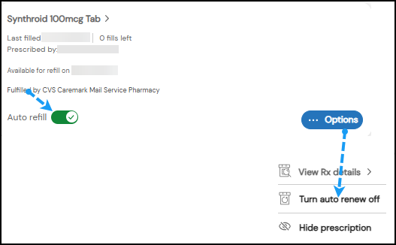

**Result:** If the toggle button is gray with an “x,” the prescription is no longer enrolled in the ReadyFill program.

* Confirmation of dis-enrollment is provided at the top of the page.

Top of the Document

|  |
| --- |
| Auto Fill Date after 16-day hold period |

The Next auto fill date displays the date prescription(s) enrolled in Auto Refill or Auto Renew will be released from the mandated 16-day hold period and begin to be filled. The ReadyFill program does not fill the prescriptions based off the plan’s utilization/next scheduled fill date.

The ReadyFill program factors in the previous fills of the drug. For ReadyFill Orders, the order will begin filling when the member has 7 days of medication on hand, according to the accumulation of all previous fills. An alert is sent to the member to advise the order will begin filling in 16 days **(after the mandated 16-day hold). This is** the same date displayed from Caremark.com All Prescriptions list.

If the member would like to fill the prescription before the scheduled auto fill date, they can un-enroll the prescription(s) from the ReadyFill program.

Viewing the Accumulation of fills and schedule Auto Refill/Renew dates.

Compass Rx Alerts:

Top of the Document

|  |
| --- |
| Related Documents |

[Caremark.com - Common Member Assistance Call Types Index (068985)](https://thesource.cvshealth.com/nuxeo/thesource/#!/view?docid=947b0b38-401d-4b18-a08e-60348558a9b9)

[Caremark.com – View/Refill All Prescriptions (018775)](https://thesource.cvshealth.com/nuxeo/thesource/" \l "!/view?docid=ca9a6da8-e7b6-4eaf-aa3d-0c75eb4a6f06)

Top of the Document

Not To Be Reproduced Or Disclosed to Others Without Prior Written Approval

**ELECTRONIC DATA = OFFICIAL VERSION / PAPER COPY = INFORMATIONAL ONLY**